**Explore Weather Trends Project**

Here are the steps to prepare data:

1. First, select the biggest and nearest city near me, use sql:

|  |
| --- |
| SELECT * FROM city_list; |

Click evaluate to get the city_list in csv file. Open csv file and use filter to filter the country as “United States”, then I can get the biggest, nearest city to me is “Boston”. Be careful, here Boston starts with capital letter.

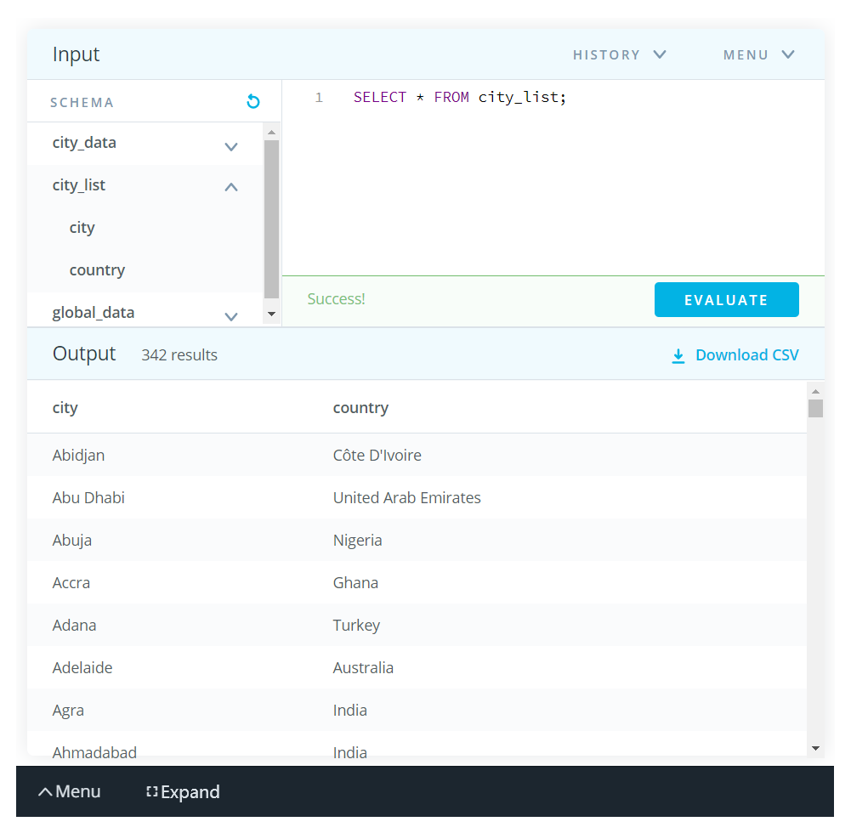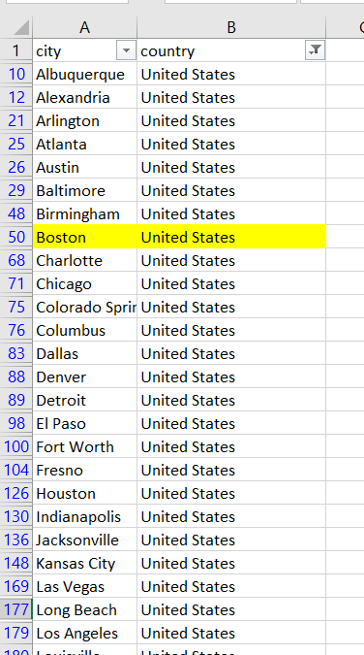

1. Then, use city_data by filter “Boston” as the city:

|  |  |
| --- | --- |
| |  | | --- | | SELECT * FROM city_data |   WHERE city='Boston'; |

Click evaluate and download csv to get the city_data in csv file.

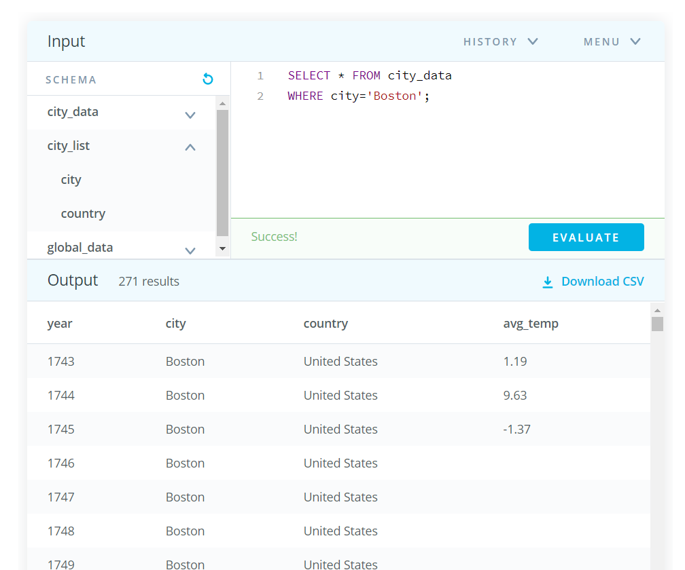

Use the same method to download global_data csv file:

|  |
| --- |
| SELECT * FROM global_data; |

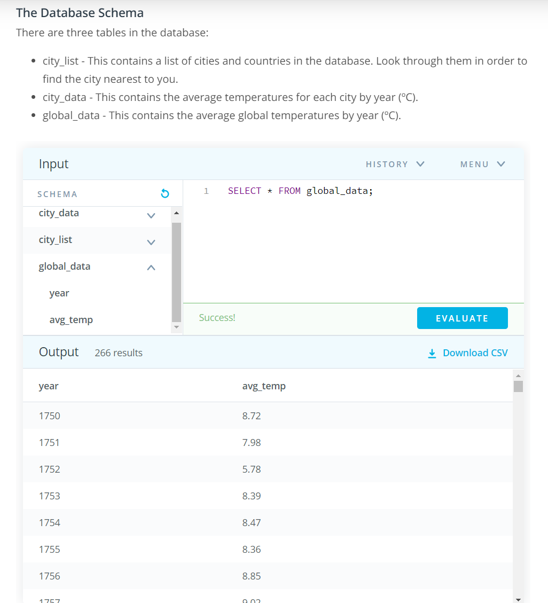

After we get the data in csv file, we need to decide to use which tools to calculate the moving averages and make it visualize the trends. In this step, I use both excel and tableau to get the line chart.

Excel steps:

1. Open new excel and save it as “Explore Weather Trends”
2. Data->Get Data->From file-> city_data_boston.csv-> import table as table to the new worksheet
3. Repeat the step 2 to import the global _data.csv
4. After we get data in the new file, we can use them without destroy the original data. Now, join two tables from two worksheet to one table. I use inner join by years, because either left join or full outer join will make a lot of null values, null values will affect the visualize step. To inner join two table, Data-> Get Data-> Combine queries-> Merge-> select city_data_boston and global_data and let them inner join by the matching year.
5. Then, use AVERAGE to calculate the 10 years and 15 years moving averages for both city_data_boston and global_data.
6. Use Insert-> Line Graphs to create the graphs for temperature trends, remember to add titles, axis titles and legends to make the graphs easy to read.
7. Here are the temperature trends graphs by every year, temperature trends graphs by 10 year moving average, and temperature trends graphs by 15 year moving average.

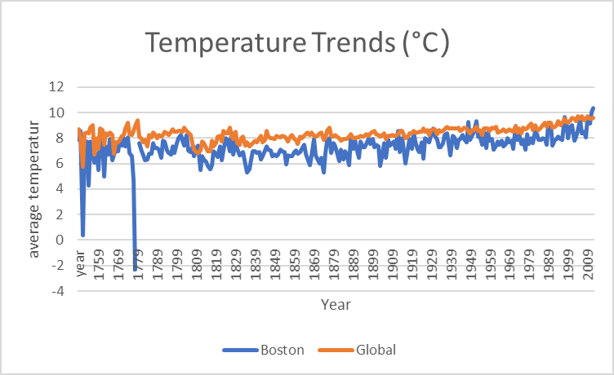

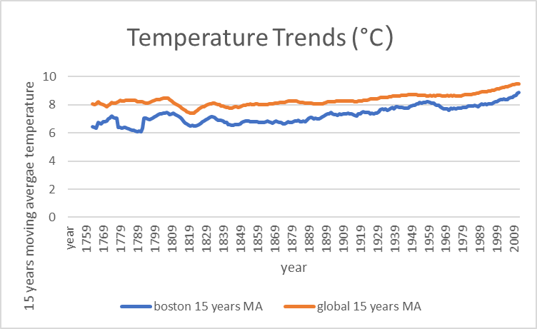

1. The graph for each year is too dense, and it cannot see the long-term trends in the graph. The 10 years moving average graph can gives us a better rends for the long terms, However, 15 years moving average graph is smoother at some point. After comparison, 15 years moving average graph will be used for my result.

Tableau steps:

1. Tableau can join table and visualize the data in much easier way than the excel. When I use excel join, excel takes long time and almost crashed at first time. Tableau also can get the graphs much easier. First, open city_data_boston and create inner join with global data in the Data Source.
2. Go to a sheet, select year in the column.
3. Select boston_avg_temp and global_avg temp in the Rows, select dual lines in the show me. Now we can get a basic temperature trends graph with average temperature per year.
4. We already know the yearly graphs cannot tell the trends of the long-term. We need to add the calculation for the data, tableau have a really easy option called “Table Calculation”, which can directly add the table calculation for the graph.
5. We do the table calculation and select moving calculation, select average and set 10 years for the for the value. I will also select “Null if there’s not enough value”, this can make my graph more accurate.

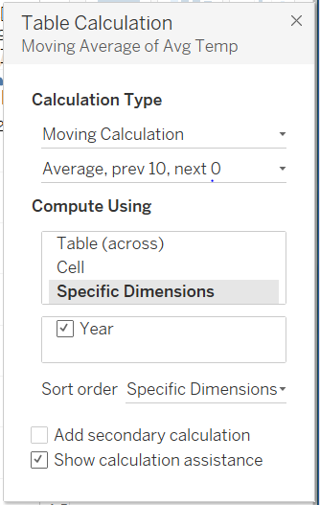

1. Repeat the table calculation steps for both Boston and global data, the 10 year graph is good to go. To make it more readable, I will create a Dashboard for the graph so that I can edit title, legends and axis title.

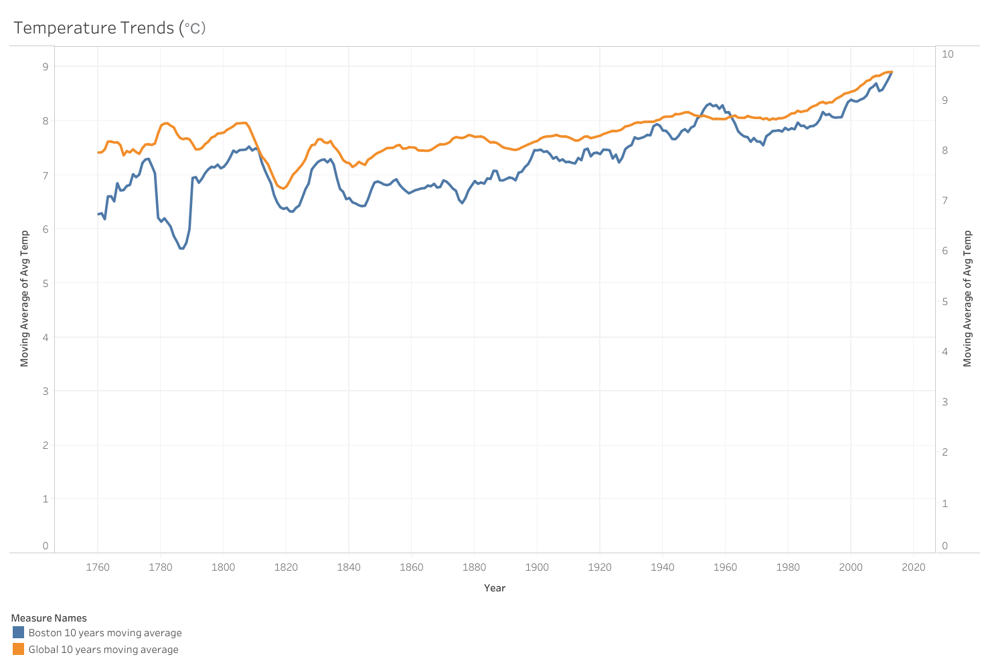

Click the link can go to my tableau public to view the graph: <https://public.tableau.com/views/temperaturetrends/Dashboard10yearMA?:language=en&:display_count=y&:origin=viz_share_link>

1. Since the graphs is not smooth, I will repeat step 5 and 6 to create other graph for the 15-year moving average of Avg Temp. Here is the 15 years moving average graph, which is perfect for the it visualize the trends.

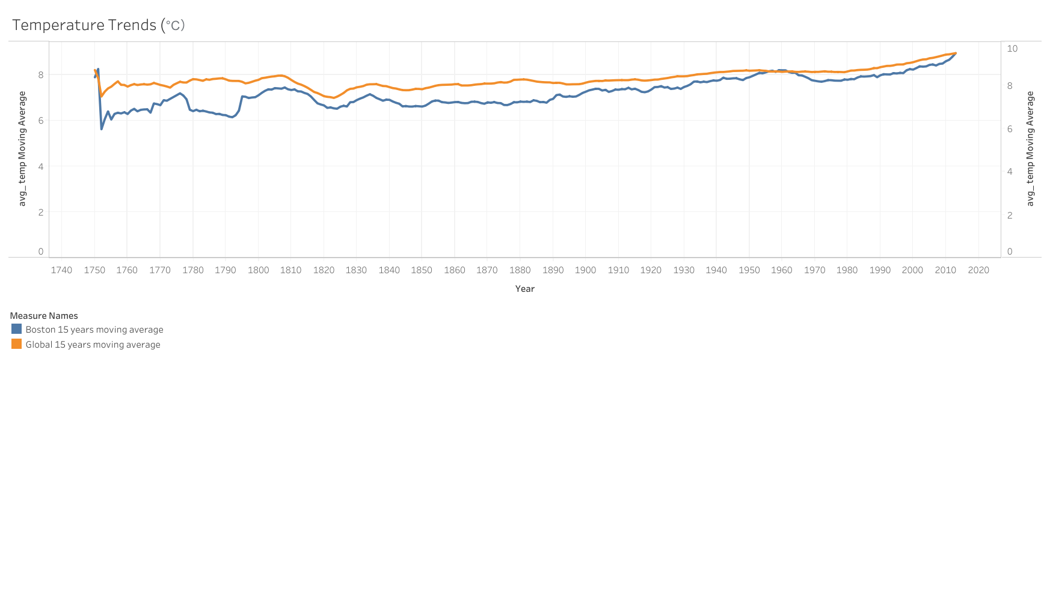

Click the link can go to my tableau public to view the graph:

<https://public.tableau.com/profile/sookie.yuan#!/vizhome/temperaturetrends/Dashboard15yearMA>

Observations:

1. My city Boston is cooler on average compared to the global average, except year 1951,1962, and 2013. In these three years, the average temperature in Boston and global is the same. Therefore, we can find Boston is always cooler on average compared to the global average.
2. From 1750 to 2013, we can see the average temperature in both Boston and global increase. However, the temperature difference of the Boston is over 3.6 °C, the global temperature difference is around 2.3 °C.
3. The overall trend is increases over the time, and the increase trend and decrease trends are almost same for Boston and global temperature.
4. From two line, we can also find Boston was cooler during the 1776-1795. However, in next two hundred years, Boston’s weather trend is same as the global. This shows a long-term global warming, and it will affect all the place. The effect of global warming in cold places will be more pronounced.